User manual – G.U.A.R.D

Version 1.0.1



Contents

1. Login 3

1.1. Registered G.U.A.R.D user 3

1.2. New to G.U.A.R.D 3

2. Connect to G.U.A.R.D 3

2.1. Bluetooth connection 3

2.2. Wi-Fi connection 3

3. Main screen 4

3.1. Manual control 4

3.2. MAP/GPS 4

3.3. Logout 4

4. Toolbar 4

4.1. Toolbar top 4

4.2. Toolbar bottom 4

5. Manual control 5

5.1. Analog controller (joystick) 5

5.2. Video stream 5

5.3. Parking sensors 6

5.4. Battery indicator 6

6. MAP/GPS 6

# 1. Login

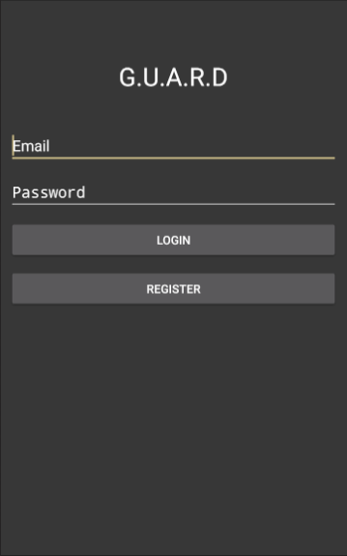When the application is launched for the first time (or if the user chooses to log out), he or she must first login before gaining access to the application.

## Registered G.U.A.R.D user

In case the user already has a registered G.U.A.R.D account, he or she may enter their credentials and press “login”, see *Figure 1* to the right.

## New to G.U.A.R.D

However, if the user has yet to create an account, he or she must go through the registration process to gain access to the application. The user simply presses the register button, see *Figure 1* to the right, and another view is shown where the user is asked to enter e-mail and password. *Notice that the password must be of at least 8 characters.* When the registration is done, the user is a registered G.U.A.R.D user and logs in accordingly (see 1.1 Registered G.U.A.R.D user above).

# Connect to G.U.A.R.D

Figure – view of login screen

G.U.A.R.D utilizes two connections to work as intended; Bluetooth and Wi-Fi. The Bluetooth connection handles the data exchange between the Arduino and the mobile device while the Wi-Fi connection handles the data exchange between the Raspberry Pi and the mobile device. For optimal user experience, both connections are recommended when using G.U.A.R.D (*absence of either connection will disable certain features*).

## Bluetooth connection

*******

## Wi-Fi connection

# Main screen

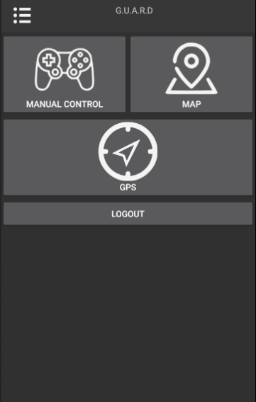When the user has logged in, the user is greeted by the main screen, see *Figure 2* to the right*.* The main screen contains various options. Clicking on of the options will redirect the user to the view of such choice.

## Manual control

Manual control allows the user to control the car manually with help of a joystick. A video stream as well as “parking sensors” are provided to aid the maneuvering of the G.U.A.R.D device. See 4. Manual control for more information.

## MAP/GPS

MAP/GPS has two usable features; a map showing both the user’s and the G.U.A.R.D device’s location as well as the possibility for the user to activate the autonomous following. See 5. MAP/GPS for more information.

## Logout

If the user wants to logout from the application, the button “LOGOUT”, see *Figure 2*, will do just so. After the user has logged out, the login screen is prompted and the user has to login again to gain access to the application.

Figure – view of main screen

# Toolbar

## Top

Plaaaaaaaaaaaaaaaaaaaaaaaaaaaaaaaceholder

## Bottom

In all views, but main and login screen, a toolbar with shortcuts is available at the bottom of the screen (see *Figure 3* below). The toolbar is intended to increase the usability of the application by providing a quick way of changing the view. Pressing one of the shortcuts in the toolbar will simply redirect the user to the chosen view.

# Manual control

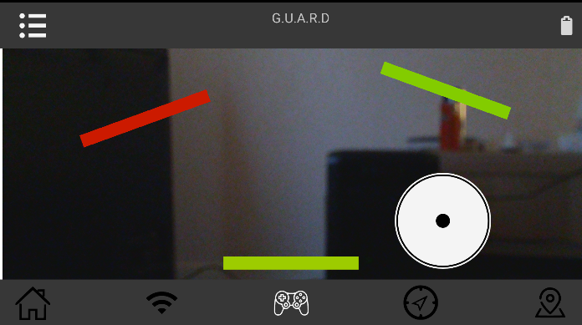The manual control feature provides the user with an intuitive way of controlling G.U.A.R.D (see *Figure 3* to the right). A digital multi-axis controller that mimics a good old fashioned analog joystick provides the user with the ability to easily maneuver G.U.A.R.D. A in real time video stream shows what is in front of the G.U.A.R.D device. To further provide the user with tools for maneuvering the G.U.A.R.D device in a safe manner, “parking sensors” which graphically indicate potential objects surrounding the device, are present in the manual control view. *Notice that an established Bluetooth connection is required for the controller and parking sensors to work* *while* *the video stream requires an established Wi-Fi connection to work.*

Figure – view of manual control

## Analog controller (joystick)

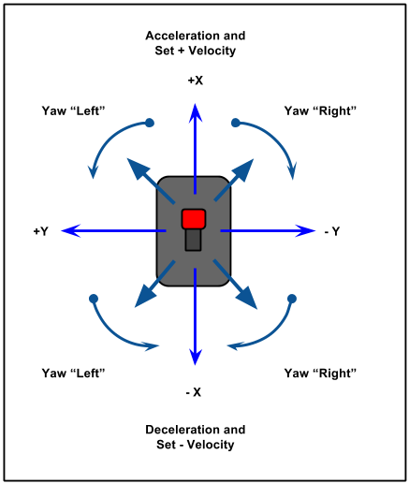The analog controller works exactly as its physical equivalence (see *Figure 3* above, white circle in bottom left corner). Pressing and holding the joystick forward will make the G.U.A.R.D device drive forward. Likewise, pressing and holding the joystick in any other way, the device will turn/drive towards the heading the joystick points at (see *Figure 4[1]* to the right for graphical guidance). The speed of the G.U.A.R.D device is directly proportional to how far the joystick is held from its center. Thus, holding the joystick as far as possible from the center, maximum speed from the device is requested. Letting go of the controller makes the joystick to automatically regress to its default position, in the center of the controller, and the device stops.

## Video stream

Figure – graphical representation of how the analog controller functions

The background of the manual control view (see *Figure 3* above) is a real-time video stream facing the front of the G.U.A.R.D device. *Notice that a slight delay (less than 500 ms on average) may be present due to hardware limitations.*

## Parking sensors

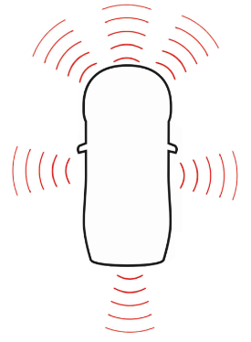The colorful lines in the manual control view (see *Figure 3* above) are the so-called parking sensors. The G.U.A.R.D device utilizes various ultrasonic sensors, placed according to the sketch (see *Figure 5* on the right). Each sensor sends and retrieves “beams” like the figure suggests and returns the distance to a potential obstacle within the beam area. If a sensor returns a number within a certain threshold, a line that overlays the manual control is shown. The color and the position of the line indicates how close the sensors senses that an obstacle is. The color changes between green and red. The redder the color gets, the closer the sensed obstacle is (see *Table 1* below for a key that shows which color corresponds to which distance range).

Figure – sketch over how the parking sensors are positioned

Table - table showing approximate distance between G.U.A.R.D device and obstacle depending on parking sensor color

|  |  |
| --- | --- |
| **Color** | **Approximate distance to obstacle in centimeters** |
| Green | 17 – 30 |
| Yellow | 12 – 16 |
| Orange | 7 – 11 |
| Red | 0 – 6 |

## Battery indicator

The manual control also contains a battery indicator in the top right corner (see *Figure 3* above). The indicator simply gives an indication of how much battery there is left in the G.U.A.R.D device’s battery pack. In case of critical low battery level, the application will both notify the user via a toast as well as a notification. The user can acquire additional details of the battery level by pressing the icon which will prompt a view containing information such as, for example, estimated battery pack voltage.

# MAP/GPS

1. Image showing two different ways of configuring a joystick. Digital image. Imgur: The Most Awesome Images on the Internet. N.p., 3 Dec. 2013. Web. 10 May 2017. <http://imgur.com/cVHe5Tr>.